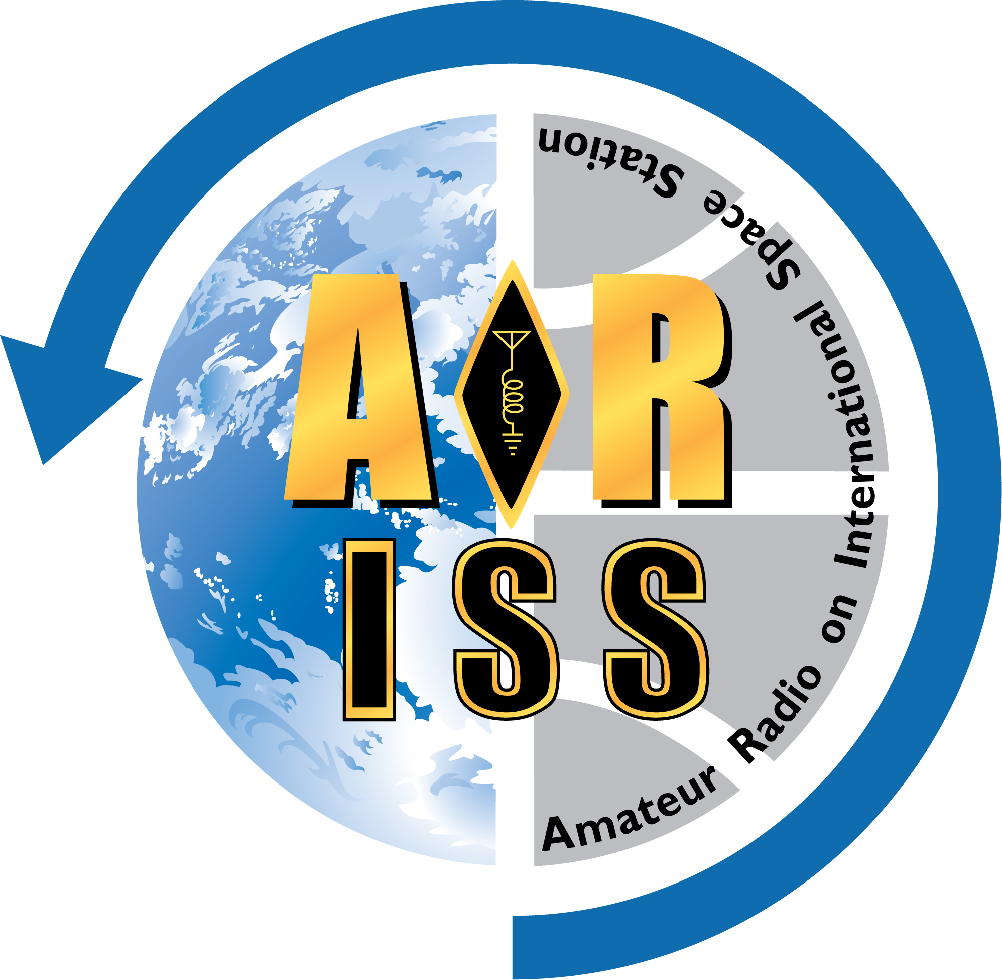

Amateur Radio on the International Space Station (ARISS)
Equipment Plan

Privacy Policy
The information you provide will be used by ARISS member organizations only for its intended purpose. Submitting information is strictly voluntary. By doing so, you are giving ARISS your permission to use the information for the intended purpose. If you do not want to give ARISS permission to use your information, simply do not provide it. However, not providing certain information may result in ARISS’s inability to provide you with the information or services you desire.

Directions
The technical team (local amateur radio group and organization’s IT representative, with guidance from the ARISS Technical Mentor) should complete this form to the best of their ability. This plan must be submitted to and approved by ARISS before you can be scheduled for an ARISS contact.
Note: ARISS recognizes that circumstances might require changes to this plan during implementation. Your Technical Mentor can approve justifiable changes if they become necessary.
When completed, save this form as a Microsoft Word document with this file naming convention:
YYYY-MM-DD, Organization Name, ARISS Equipment Plan.docx
Submit the completed form to your Technical Mentor, who will review it and forward it to the evaluation team.
Send any questions or comments about this form to ariss@arrl.org.

General Contact Information

Type of contact requested: ☐ Direct
☐ Telebridge

Contact Site Primary Phone #
Must be a hard-wired (landline) phone
Contact Site Backup Phone #
Can be a landline or mobile phone
Contact Site Time Zone  UTC is Coordinated Universal Time | Time Zone Name:  Hours before/after UTC:
When is your area on Daylight Saving Time?

Information for Direct Contact

Complete this section for a direct contact.
Some of the information requested here might not apply to your installation; where appropriate, enter “none” or “NA” (not applicable). You should not interpret these questions as requirements. Refer to the ARISS Ground Station Recommendation and your Technical Mentor for suggested equipment.

Call sign to be used during contact:

Radio Coordinator

Ham Radio Team Lead  Local ham radio operator coordinating the ground station | Name and call sign:  Mailing address:  E-mail address:  Landline phone #:  Mobile phone #:
Briefly describe the team lead’s experience with weak-signal satellite operations, if any.

Contact Site

Location  Address of contact site and brief description (for example, “1st floor auditorium”) | Street:  City, State, Zip:  Description:
Coordinates  Geographic location of site, for calculating ISS passes. Provide lat/long in decimal degrees (for example, “39.392 N”). | Latitude:  Longitude:  Elevation (meters above sea level):
Horizon  Note any antenna obscurations (minimum horizon in degrees). For example:  Azimuth (degrees) Elevation (degrees)  0 – 50 0  50 – 90 15  90 – 100 30  100 – 140 5  140 – 280 10  280 – 360 5 | Azimuth Elevation

Briefly describe how audio will be distributed during the contact (student/PA microphone to transmitter, receiver audio to PA, and so on).

Radio Station #1 (Primary)
Transceiver
Manufacturer and model:
Number of memories that support non-standard split and 1-kHz resolution:
Output power (watts):
Frequency range (MHz):
Minimum tuning resolution (kHz):
Transmit amplifier
Manufacturer and model:
Maximum output power (watts):
Receive preamplifier
Manufacturer and model:
Location (in station or at antenna):
Antenna
Type (such as single or crossed yagi):
Manufacturer and model:
Gain (specify dBi or dBd):
Number of elements:
Polarization (such as horizontal or right-hand circular; specify if switchable):
Rotator
Type (none, azimuth, az/el):
Manufacturer and model:
Coax
Type:
Approximate length:
Tracking program
Name:
Automatic rotator control (yes/no):
Other station equipment
Power source: (such as UPS or battery):
SWR/output power meter (yes/no):
Packet capability (yes/no):
SSTV receive capability (yes/no):

Radio Station #2 (Backup)
Transceiver
Manufacturer and model:
Number of memories that support non-standard split and 1-kHz resolution:
Output power (watts):
Frequency range (MHz):
Minimum tuning resolution (kHz):
Transmit amplifier
Manufacturer and model:
Maximum output power (watts):
Receive preamplifier
Manufacturer and model:
Location (in station or at antenna):
Antenna
Type (such as vertical or crossed yagi):
Manufacturer and model:
Gain (specify dBi or dBd):
Number of elements:
Polarization (such as vertical or right-hand circular; specify if switchable):
Rotator
Type (none, azimuth, az/el):
Manufacturer and model:
Coax
Type:
Approximate length:
Tracking program
Name:
Automatic rotator control (yes/no):
Other station equipment
Power source: (such as UPS or battery):
SWR/output power meter (yes/no):
Packet capability (yes/no):
SSTV receive capability (yes/no):

Information for Telebridge Contact

Complete this section for a telebridge contact.

Audio Coordinator

Main Audio Point of Contact  Person coordinating the audio arrangements for the contact | Name:  Mailing address:  E-mail address:  Landline phone #:  Mobile phone #:

Audio Information

Type of Phone System
Analog or digital
Method of Connecting to Phone Line
Hardware manufacturer and model, etc.
Briefly describe how audio will be distributed between the PA system, phone line, and any other connections.

