THE TRANSATLANTIC TESTS

The Great War was over. Amateur radio operators on both sides of the Atlantic returned to their keys and contemplated the challenges of long distance communication. A decade ago the self professed “amateur” Guglielmo Marconi had sent signals from Canada and the United States to England. The Marconi Company was providing increasingly reliable commercial communications both ways across the Atlantic while amateurs limited in transmitting power and scale gradually improved their abilities. Following Marconi’s lead the English amateurs looked west and the U.S. amateurs looked east to reach the next historic amateur radio milestone. Both shores organized to bring this feat about.
Their efforts to transmit signals easterly and later westerly across the Atlantic were exerted over a three year period. At first the tests were one way exercises in being heard and culminated with the first two way transatlantic QSO in 1924. The main event, which generated the most excitement and received the greatest publicity, was the second one way test conducted from the United States to Europe in December of 1921.
The First Trial-1921
Early on Hiram Percy Maxim, President of the foundling American Radio Relay League (ARRL) had editorialized that, beyond the domestic relay tests that the League regularly conducted, the next hurdle was the Atlantic. The Board of Directors of the Radio Club of America also advocated an effort. The war intervened but, shortly after the Armistice Britain took the initiative. M.B. sleeper editor of Everyday Engineering magazine, proposed a plan for transatlantic experiments. The magazine intended to conduct the program utilizing its own resources however, faced with a financial crisis, publication was suspended. The ARRL hurriedly assumed the leadership of the project.

The experiment was to test one way transatlantic communications from the United States’ more powerful transmitters to receivers in Britain. The test was scheduled for the nights of February 1, 3 and 5 of 1921. Twenty five almost entirely U.S. east coast stations were selected to transmit designated signals at precisely designated times on 200 meters. The Wireless Society of London through the auspices of Wireless World and Radio Review magazine arranged for 250 British listeners. This test was a failure! Not one of the U.S. stations was heard !
The Second Trial 1922
The misfortune was attributed to the poor design and sensitivity of the English regenerative receiving equipment which produced self interfering heterodynes; harmonics from commercial press stations; inference from a Royal Navy station; the short period of time permitted for individual transmissions; and the fact that most of the transmitting stations were using spark. Controversy prevailed. Encouragingly, reports of reception were received from American ships plying the Atlantic which obviously were equipped with superior receiving equipment. But, that only heightened the controversy. The failure was a topic of great interest at a unique event which was to have great impact on the challenge.
In these formative years, the ARRL made significant decisions which were to strengthen its federation and contribute to its future. Among them was the decision to encourage and participate in regional amateur radio gatherings. These events bound the early constituents. Prompted by the interest in these meetings, the leaders of this group, of maverick hobbyist’s, determined to convene a full scale national convention. This audacious action is consistent with the spirit of enthusiasm and energy which propelled the fraternity of less than 6,000 members among a total census of approximately 8,000 licensed U.S. operators.
On August 31, 1921 President Hiram Percy Maxim convened the assembly in the city of Chicago, Illinois. Among the attendees, the principal interests were the failed transatlantic tests, operating practices and the relative merits of spark gap transmitting and the recent introduction of vacuum tube continuous wave transmission. Addresses, seminars, technical papers, ands special interest group meetings kept the twelve hundred attendees occupied. The affair was a great success with something for everyone. More than twelve hundred amateurs attended from every state in the U.S.
The Board of Directions (sic) of the League met during the affair with thirteen Directors present. Responding to the enormous interest in the Atlantic challenge, it was decided to mount a second transatlantic test in December of that year and to send a receiver expert to Scotland to listen for U.S. Signals.
Accordingly, the staff of the League began to plan for a second transatlantic test to include what was thought essential-the presence of an American expert, equipped with the most modern receiver at the European receiving end. The ARRL Board selected receiver circuit designer, Paul F. Godley for this assignment. Godley, was a member of the ARRL Advisory Technical Committee, the Institute of Radio Engineers and the Radio Club of America., Godley was considered … “the most expert operator in the practical reception of short wave signals” said the General Manager of the ARRL. The intent was for Mr. Godley to augment but not supersede the British listening effort.
And so the intrepid went forward. Preliminary distance trials, held in November, qualified twenty seven station finalists. Each station was assigned a group of sealed secret code letters and specific and rotating transmission times. The operating window was set as the period of 9:30 PM to 1:00 AM EST on each of the ten consecutive days December 7 to December 16. Non- qualifying stations were encouraged to transmit from 7:00 PM to 9:30 PM EST on each evening during time segments divided into rotating 15 minute segments by district. The rest of the U.S. amateurs were asked to remain silent.
Godley received a rousing send off in New York and the second day out received a radiogram from the ARRL….”Bon Voyage. The entire radio world is pulling for you”.
At Southampton he was greeted by personnel of The British Marconi group who assisted him in clearing his apparatus and set him on his way to London. In London he was received enthusiastically by other amateurs and notables. The staff of “Wireless World” magazine, organizers of the British side of the planned test was particularly helpful. Godley attended meetings of the Royal Society of the Arts and the Wireless Society of London where he met Senatore Marconi and Dr. John Ambrose Fleming and other scientific and radio notables. The Wireless Society hosted an elaborate tea and a dinner in his honor. Godley reported after the tests had concluded that while in London he sensed a level of skepticism below the veneer of enthusiasm. This he attributed to the highly restrictive conditions that were imposed on that nations amateurs by the controlling British postal authorities. So restrictive were these rules pertinent to operating wave length, power, antenna length etc. that it was difficult for British amateurs to imagine the successful accomplishment of the feat that was being undertaken.
From London Godley traveled to Glasgow where with the assistance of the superintendent of the Marconi International Marine Communication Company he obtained the necessary material to establish a listening post at the farm from which he intended to listen-tent, wire, insulators etc. The site was by the sea on the Ardrossan moor near the town of that name on the North Ayrshire coast in south western Scotland thirty miles from Glasgow.
The listener and a local Marconi man acting as verifier, Inspector D.E. Pearson, established themselves in the cold tent at midnight on December 7. The receiver a battery powered Super-Heterodyne and regenerative receiver with five stages of amplification and a 1300 foot Beverage antenna suspended 12 feet above ground were set up and tuned. At about 1:30AM a 60 cycle synchronous spark signal from 1AAW was distinctly heard on 270 meters, but only briefly and not in test format. This, the first station to traverse the Atlantic albeit it unofficially, was later determined to be a unlicensed pirate who the ARRL was later unable to identify. The duo continued to listen on the subsequent mornings of December 8, and 9 to no avail. On the morning of the 10th the CW signals of official entry 1BCG, were solidly heard on 230 to 235 meters. This, the specially designed and constructed station of the Radio Club of America at Greenwich, Connecticut was the only station heard that morning. During the nights and early mornings that followed until the end of the test eight spark and eighteen CW stations were heard. Eight English amateurs heard eleven stations and five listeners logged 1BCG. A Dutch and a French amateur each heard signals from the U.S. 4,000 miles away. Surprisingly, many of the stations that qualified in the preliminary tests were not heard in Europe. Conspicuously the CW mode won the day adding the final blow to the demise of spark. The results were boastfully exclaimed on the cover of the January, 1922 issue of QST magazine.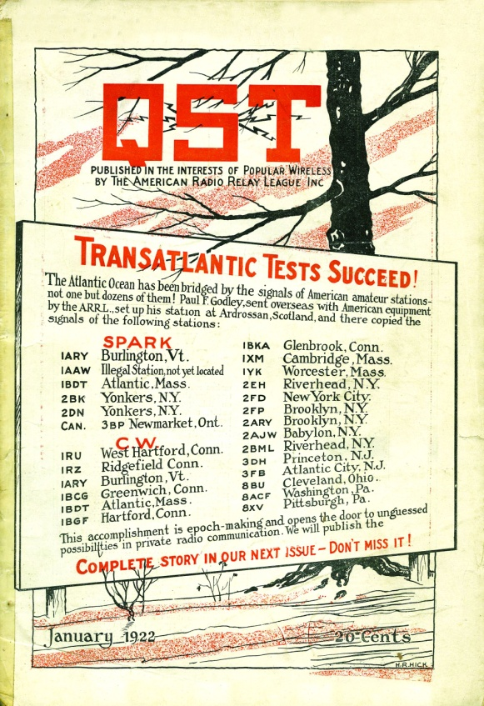
Today, on this site in Scotland, a weathered bronze plaque is to be found.
NEAR THIS SITE IN DECEMBER 1921, RADIO SIGNALS TRANSMITTED BY
RADIO AMATEURS WERE FIRST HEARD ACROSS THE ATLANTIC. AMERICAN
ENGINEER PAUL F.GODLEY SELECTED ARDROSSAN AS A QUIET SPOT FOR
RADIO RECEPTION, AND SPENT SEVERAL LONG WINTER NIGHTS IN A TENT
WITH HIS RECEIVING APPARATUS. HE WAS REWARDED WITH CONFIRMED
RECEPTION OF MORE THAN 30 DIFFERENT AMATEUR RADIO STATIONS IN
CANADA AND THE UNITED STATES, THUS PROVING THAT VAST DISTANCES
COULD BE SPANNED BY RADIO WITHOUT MASSIVE COMMERCIAL
INSTALLATIONS.
ERECTED IN DECEMBER 1989 BY THE RADIO SOCIETY OF GREAT BRITAIN
TO COMMEMORATE THE 75TH ANNIVERSARY OF THE FOUNDING OF THE
AMERICAN RADIO RELAY LEAGUE, SPONSOR OF GODLEY’S EXPEDITION.

The Third Trial-1922
With barely a respite, planning began for the third test which was scheduled for the end of the year 1922. This test was to be conducted on a much broader scale than the previous two. The objectives were to give American stations the opportunity to be heard not only in the Britain Isles but also on the continent. And, and to provide a generous period for the regulatory disadvantaged westbound signal to be transmitted to the U.S. The intricate planning for this event was shared by the ARRL, the Radio Society of Great Britain, and an amalgamation of three French radio societies, the Comite Francais des Essais Transatlantiques.
A sophisticated and essential element in the program was the method for informing the world of interceptions. It was arranged that reports of successes would be forwarded to the transmitting nation by commercial long wave stations. English stations were to report to the U.S. by MUU Carnarvon, Wales on 14,200 meters and French stations were to report via UFT on 14,300 meters. These reports were repeated by the U.S. station WII in New Brunswick, New Jersey. In the reverse U.S. reports were to be transmitted to Europe via WII.
The publicity of the partial success of the second trial aroused a great deal of interest on both sides of the ocean. Throughout the year 1922, popular radio enthusiast magazines featured equipment reviews, articles on every aspect of receivers and transmitters, and the details and protocol for the tests. International enthusiasm was intense as the preliminary qualifying trials were held on both continents in October on 180 through 200 meters. The air waves literally pulsed with excitement as the official start was approached.
Radio history was going to be made and indeed it was! During the first ten day session from December 12th onward 316 American stations including three from the far western reaches of the continent were heard in Europe. Even more exciting was the news that during the second session 20 different U.S. amateurs heard European amateur signals. These emanated primarily from the French station 8AB and British station 5WS.
British station 5WS at Wandsworth, mounted by the Radio Society of Great Britain, was unique in that it was entirely modern and by special dispensation of the General Post Office was permitted to use up to a kilowatt of power.

The First Two way Contact-1923
The exploits of French station 8AB in late 1923 over shadowed the upcoming fourth trial. The station 8AB was operated by Leon Deloy and was located in Nice. This amateur was determined to transmit his signals across the Atlantic. A late 1921 effort to contact Connecticut station 1KP on a prearranged schedule did not succeed. Undeterred, Deloy attended the second ARRL national convention in Chicago in mid 1923. There and in visits with prominent U.S. amateurs he acquired knowledge of American amateur methods and apparatus. He returned to France with American radio gear he had purchased and assembled a new station which was acclaimed as the most advanced on the continent. By October of the year, he conducted successful tests of his new station with British 2OD and informed the ARRL by cable that he was prepared to make two way contact with U.S. stations. The night of November 27, 1923 radio history was again made when 8AB established strong contact with 1MO operated by ARRL staffers F.H. Schnell and K.B. Warner at Hartford, Connecticut and immediately after with 1XAM operated by transmitter designer John l. Reinartz from a Hartford suburb. The U.S. stations had special authority to make these contacts on 100 meters and all three stations used the CW transmitter circuits developed by Reinartz utilizing a Westinghouse 50 watt vacuum tube. The France-America connection was quickly followed by a British-American connection between G2KF and 1MO; and a British-Canadian contact between G2OD and C1BQ. Certainly very exciting times!
But, the excitement was not over yet! To those who were aware of these recent accomplishments the aura of expectation of what was to come was great.
The Fourth Trial 1923
While these two way contacts were being achieved the planning for the last listening test was under way. Only westward transmissions were to be monitored from December 22, 1923 to January 10, 1924. U.S. stations were silent during the period. Thirty seven official and five unofficial European stations were reported as heard by one hundred U.S. stations on 108 to 118 meters. This was a remarkable improvement over the previous westward test when only two European stations, of a special nature, had been heard.
Two way contacts across the Atlantic became common and an increasing number of European countries began to participate. U.S. stations turned their attentions eastward to spanning the Pacific to Australia and New Zealand.
The benefits of these tests were many. International camaraderie strengthened; CW prevailed over spark; the effectiveness of the shorter wavelengths was proven; technological improvements were spurred; amateurs received needed notoriety and last but not least, amateur radio history was made.
MWM 8/23/2014

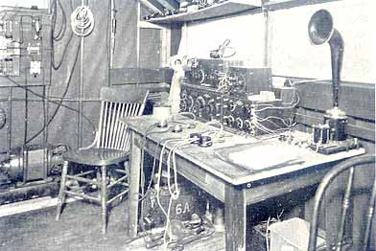
RECEIVER SET UP AT 1BCG

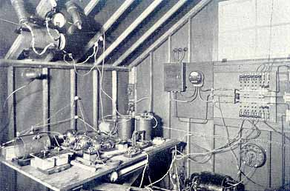
TRANSMITTER ARRANGEMENT AT 1BCG

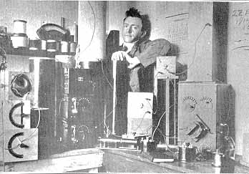
PAUL F. GODLEY AND VARIOUS RECEIVERS

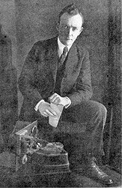
PAUL F. GODLEY 1
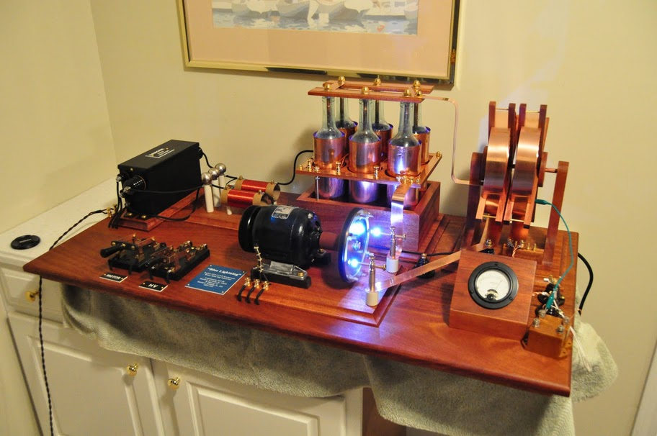
MODEL OF SPARK GAP TRANSMITTER
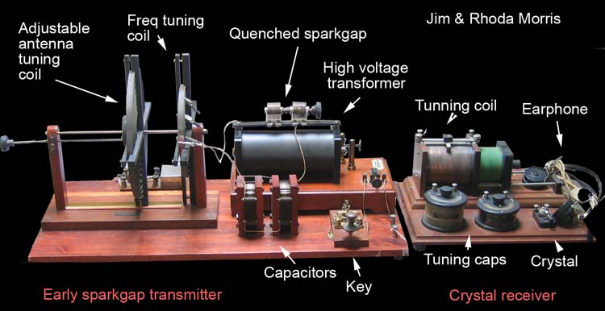
SPARK GAP STATION ARRANGEMENT
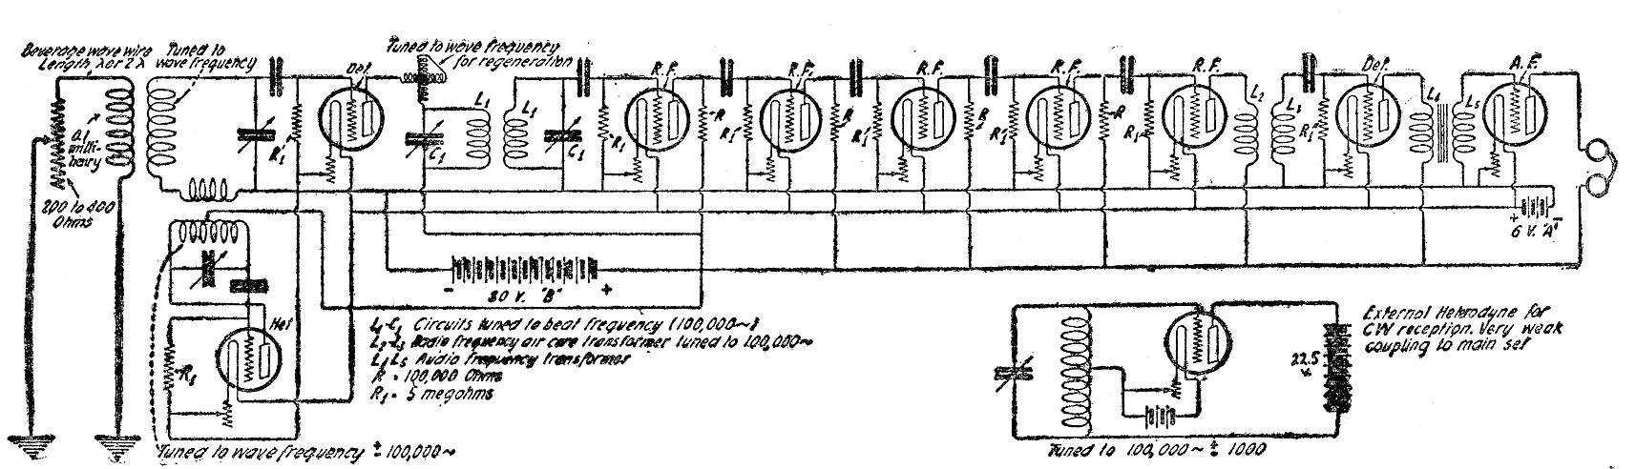
GODLEY'S RECEIVER

