ARRL’s sample World Amateur Radio Day Media Advisory
Use radio club letterhead. Keep to a single page.
Contact:
[LOCAL CONTACT’s NAME] [LOCAL CONTACT’s TITLE, if any]
[EMAIL]
[PHONE]
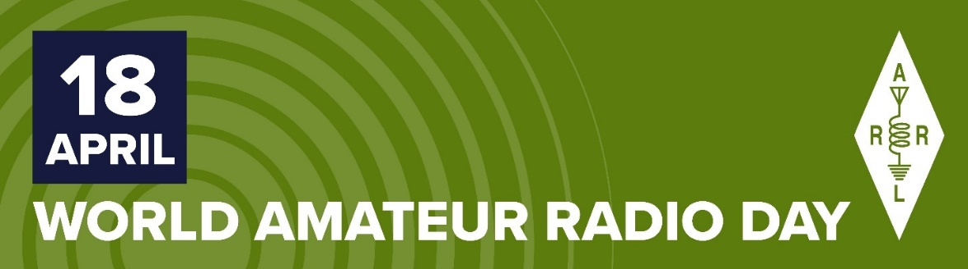
MEDIA ADVISORY
2021 World Amateur Radio Day — Sunday, April 18
[alt headline] Ham Radio Connects During a Time of Social Distancing

2021 World Amateur Radio Day (WARD) is Sunday, April 18. On this day in 1925, the International Amateur Radio Union was formed in Paris, France. World Amateur Radio Day celebrates the pioneering achievements and ongoing service of radio amateurs, also known as ham radio operators. The theme for 2021 WARD is Amateur Radio: Home but Never Alone, acknowledging the variety of activities and opportunities in ham radio that help overcome the feeling of social isolation experienced by many of us during the current pandemic.

ARRL, the national association for Amateur Radio® (www.arrl.org) in the US, reports that there are more than 3,000,000 radio amateurs throughout the world. ARRL includes 2,400 affiliated radio clubs nationwide. While physical distancing has limited many in-person activities to reduce the spread of the COVID-19 virus, many members of local radio clubs such as ________[name of your club] in ________[name of your community] are using their home radio stations to continue to practice their personal radio communications capability. Their use of radio signals, which reach beyond borders, brings people together culturally while providing essential communication in the service of communities.
In today’s electronic do-it-yourself (DIY) environment, ham radio remains one of the best ways for people to learn about electronics, physics, meteorology, and numerous other scientific disciplines. Some hams, including members of the ________[name of a local ARES® or other public service group] train throughout the year to serve their communities during emergencies and disasters, such as hurricanes and wildfires, if the standard communication infrastructure goes down.

There are hams of all ages, from 9 to 100. Many radio clubs provide support and training to help newcomers pass an Amateur Radio License examination. A self-study license guide is available from ARRL: The ARRL Ham Radio License Manual (www.arrl.org/shop/Ham-Radio-License-Manual) and for Kindle (www.amazon.com/dp/B07DFSW94G/ref=cm_sw_em_r_mt_dp_U_63WmEbTX76KAB).

For more information about World Amateur Radio Day and ham radio, contact ________[club or personal contact info] and visit www.arrl.org/what-is-ham-radio. Look for #WorldAmateurRadioDay posts on social media.
###

