Maximizing the Mobile Motorist Mission — Part 2 Setting it Up
See the article in September 2008 QST for why you want to—here’s how to make it happen.
Bob Bruninga, WB4APR
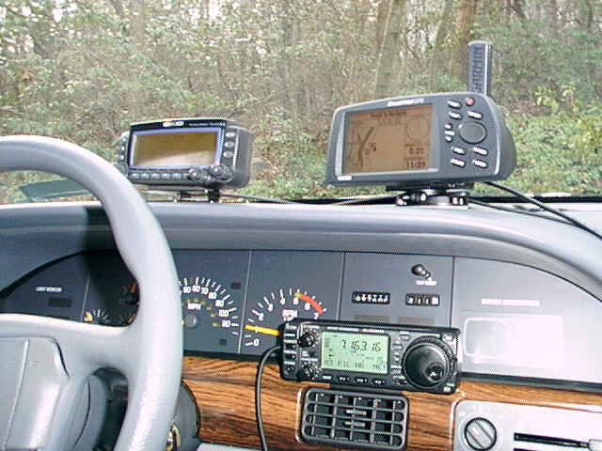

Figure 1 — W4HFZ’s typical mobile setup includes VHF, UHF, HF, a GPS and APRS.

Radio Setup
The best way to configure a mobile is to have one radio for APRS and voice alert and your other radio for voice. Or, rather than having two radios, the dual-band TH-D7 and TM-D700 series radios as well as the new VX-8R have both functions combined into one radio. The best configuration for these radios is to dedicate Band A to APRS and voice alert on 144.39 in North America and then use Band B for everything else from 2 meters, 220, 440 through 1296, (though you can only transmit on 2 meters and 440).

Common APRS Settings
The common convention is to set your call sign with an SSID of –7 if you are using a handheld, and to use –9 for your mobile. Most of the APRS menu items are self explanatory, but the most important setting not found in the APRS menu is under the RADIO-DISPLAY menu where you should set the DISPLAY-MODE to 3. This puts the APRS softkeys on the front panel for rapid access to the APRS LIST and BEACON buttons which are the most useful to the APRS traveler. Without this setting, APRS functions are hidden from the front panel and are not as convenient as they should be. The ’D710 has a hot key to toggle between soft key menus without the press-and-hold function on the ’D700. There are numerous web pages with suggestions on setting up the various APRS radios for optimum APRS.⁶

Global Real Time Messaging
Although APRS on RF is only a local system, it is globally connected for station-to-station messages. APRS has had local and global text messaging for 10 years. This is because all APRS messages transmitted anywhere all get captured into the APRS-Internet system (APRS-IS) by home stations linked to the Internet. If any such Igate anywhere sees the recipient of your message in its local RF area, it will automatically pull that live message packet from the APRS-IS and send it in real time to RF to the targeted user. His system will generate an ACK that will travel the reverse route to the sender in real time. This is not e-mail. These messages are live. If the recipient is not on the air, the message dies. No routing information is needed, just the sender and receiver call sign. If both stations are on the air anywhere in the global APRS system, their packets get to each other without any prior routing or address knowledge required.

Weather
A real advantage of mobile APRS for the traveler is the ability to look ahead and see the live weather conditions. Simply look on the APRS map or station list for an APRS weather station ahead of you. The weather data can give you valuable information on a passing front, rapid temperature changes, or rainfall and high winds. The image below is a HAMhud-2 showing a weather report.
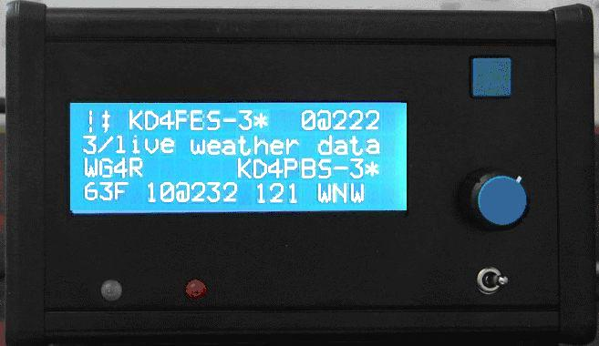

Figure 2 — This HAMhud display shows an APRS weather station with winds 10 MPH at a direction of 232° and the station is 121 miles away to the WNW..

E-Mail
In addition to live real-time global messaging, you can also use APRS to send one-line e-mail to anyone from your mobile, complements of the APRS e-mail Engine maintained by the Sproul Brothers, WU2Z and KB2ICI. Simply address your normal APRS message to E-MAIL and enter the e-mail address as the first word of the message line. Their WU2Z e-mail engine at Rutgers University will capture the message and wrap it up as normal e-mail and send it to the Internet. The e-mail engine will also send back a confirmation that the E-mail was sent.
This e-mail capability is the basis for APRS emergency messaging in disaster areas or for first responders. This capability (including via the APRS satellites) make it possible to send an e-mail from almost anywhere in the world at least a few times a day. Recognizing the great potential for this system, all ham radio operators are encouraged to transmit a simulated emergency test message via any of the APRS satellites at least once a month to validate their abilities. See www.ew.usna.edu/~bruninga/sset.html.⁷

IRLP and ECHOlink Setup
To have your local IRLP and Echolink nodes show up locally on APRS, there are two steps. First, in your IRLP or Echolink node software, enable the script that generates your node’s APRS object onto the Internet.³ Then contact your local APRS IGate operator and ask him to add the NODE name of this object to his pass-to-RF list. This way, your IRLP or EchoLink node will easily generate the object, but the local IGatge will put it on the air for you. These packets should only go direct or via one hop from the local IGate.
It is important for Igates not to abuse these objects. If Igates transmit these objects over wide areas, beyond their immediate accessibility, then they are just adding interference and spam to the channel and undermining the local utility of APRS. The coverage of these objects should be limited to only the area where these assets can be used directly.

Winlink Emergency Access
Following the Katrina emergency during which most of the e-mail and commercial communications systems were wiped out, it became obvious that any APRS radio should be able to be used to send and receive e-mail via the extensive Winlink e-mail/packet system. Although Winlink is accessible via a TELPAC node with a PC connected to a packet station, in an emergency an APRS radio operator might not have his laptop with him. We needed an abbreviated method that could be used with just the keypad and front panel in emergences if an external PC was not available. We proposed this to the Winlink community and as a result, Lee Innman wrote APRS-Link.⁸ This software monitors the global APRS Internet system and will respond to any APRS mobile radio that sends an APRS message requesting to read his e-mail. For more information on this capability, Google for APRSlink. Again, this is a last-mile, typically emergency access method, since it uses the small display and keypad for communicating, but it works when you have no other method to get the e-mail connectivity you need. To use this system, you must set up a free Winlink account if you want to be able to use the Winlink system.

Satellite Alerts
Not only are there several APRS satellite digipeaters in space, but there are numerous satellites that you can operate FM voice to while mobile with your FM rig.⁹ The problem is that most of us are simply not attuned to the dozen or so passes per day when we could be operating the satellites if we just knew they were in view. It turns out, your APRS radio or HAMhud can instantly alert you and everyone else in your region any time an FM or APRS satellite comes into view. All it requires is someone in the area to set up a satellite-object server.
The satellite will appear as any APRS object on the front panel of your radio showing you not only the call sign, name, location, distance and direction from you, but also it will show the frequency and even the current Doppler! In other words, everything you need to know will be on the front panel of your radio. In addition, once every 10 minutes a satellite schedule is transmitted to your mobile of any satellites that may come into view in the next 80 minutes.
Over the years, dozens of AMSAT satellites could be worked from the mobile FM rig including SAREX, ARISS, SUNSAT, ECHO, UO-22, UO-23, PCSAT1, PCSAT2, SO-41, SO-50, ANDE, RAFT and GO-32. Unfortunately, at this writing, only ECHO, GO32 and sometimes ARISS and PCSAT-1 can be used reliably for packet and AO-50 and AO-51 (ECHO) for voice.
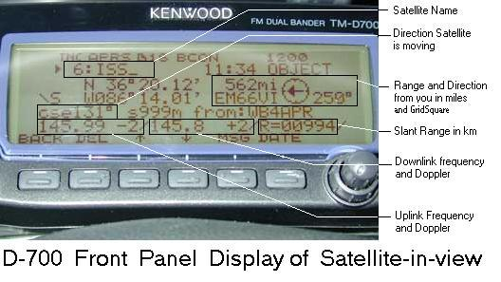Figure 3

Settings
Satellite Alerts are only visible if someone in your region is running an APRS data resource server such as the old DOS program called APRSdata.EXE. This program runs automomously at someone’s shack keeping track of all the Amateur Satellites of use to mobiles. If anyone of them comes above the horizon in your area, the software begins generating 1 minute updates to an APRS object and transmitting this object out to the region. These objects will appear on the front panel of everyone’s APRS radio or HamHUD display in the area as shown in Figure 4.
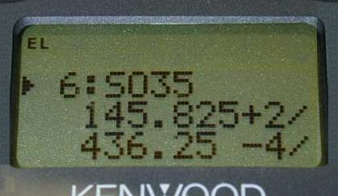

Figure 4 — In-View Satellite data on the D7 screen shows the operating frequencies and present Doppler. Other displays on the D7 show the direction and distance.
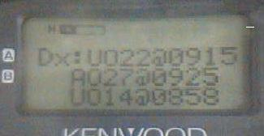

Figure 5 — A special satellite schedule packet is transmtted every 10 minutes to update this display in the D7’s and D700’s DX list. It can show up to four of the upcoming satellite passes expected in the local area. This one showed the times of the next UO22, AO27 and UO14 satellites.

Queries
As long as someone is running APRSdata or a similar local APRS server in your region, any resources in the entire area are also made available to mobile operators for query. There is no limit other than the data entered by the sysop of the APRSdata (or infoKIOSK) program. Typical queries might return the closest hospital, school, fast-food, or even Radio Shack to you. Or any other data list such as the closet club, EOC, fire station or weather station. The only limit is what the APRSdata sysop has listed in his APRSdata support files

Traffic Flow
Another useful application that was written back around 2000 would place objects on the APRS maps and mobile displays that would alert users to the speed of traffic past certain traffic speed monitors.¹⁰ Figure 6 shows how one of these objects displayed on the D7 mobile. This application runs on a local PC and monitors all APRS mobiles. Whenever a mobile passes one of these pre-determined monitoring points, its speed is recorded and turned into a fixed object at that point. These objects are transmitted once every few minutes for the next hour or so.
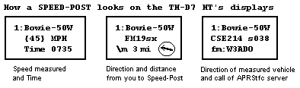

Figure 6 — The speed post object shows the location by its name, the speed and the time. The radio also can display the direction and distance and the actual course and speed of the APRS probe car that instigated the report. This one shows that traffic west bound on Route 50 at Bowie is moving at 45 MPH at 0735 AM. This speed post is 3 miles to my west with traffic going by at 38 knots on a course of 214°. (45 MPH).

Waypoints, Map Marks, Traffic Alerts
Mobile operators can even use their APRS radios to place APRS objects on the maps of all APRS users in the area. This is useful if you want to report a traffic jam, an accident, a speed trap or anything else you want other APRS users to see on their maps. You do this by simply temporarily changing your APRS mobile radio call sign to the NAME of the object you want to uplink. Include in your status text the nature of the object for all to read, and then transmit it a few times.
This position report with the new NAMEwill appear on the map at your current location. Then be sure to change your call sign back to your call and keep moving. The named object will remain on everyone’s screen at its original position, even though you keep moving. This is simplified by setting something like ALERT-X as a permanent call sign in one of your program memories.
The reason to randomly choose an SSID is because all alert objects from other mobiles will usurp each other unless they are unique. So choosing an SSID will reduce your chance of being usurped by a factor of 16 to 1. Or you can use other names such as MARK-N, SPECL-N, LOOK-N or HERE-N. In the status text is where you will tell people what it is about.
Typically you might be mobile and mark an accident. Then you can tell other APRS operators by voice or by an APRS message bulletin saying something like Accident at my MARK-N. They can then see the mark on their GPS map.
Remember, the APRS radios have several pre-programmed STATUS texts to choose from in each of the program memories (PM). If one of them is pre-loaded with ACCIDENT @ MY MARK-N then you can post this object with only a few button pushes. One to select the PM with the MARK-N call sign and another to select the pre-programmed status text. Done.

APRS Check-ins Using Any DTMF Radio.
At the 2001 RAC convention and then at Dayton in 2002, we introduced the capability to convert DTMF tones from any handheld or mobile radio to APRS information. This capability called APRS-Touchtone or APRStt has the potential to revolutionize ham radio by letting anyone with a DTMF radio check-in to the APRS system, not just those with an APRS radio.¹¹ By just keying in one’s call sign into a DTMF memory only once, then one can check-in to APRS at any time with just a single key press. See Figure 7.
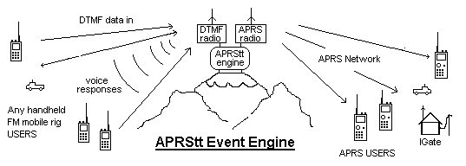

Figure 7 — APRStt even engine concept.
Just a call sign heard on DTMF on a repeater conveys almost 90% of what is important in APRS. Hearing that DTMF string, the APRStt repeater can forward all of the following information into the global APRS system:
● Call sign, Date and Time of check in.
● Position (shown within the 1 mile vicinity of that APRStt repeater).
● Frequency, tone or DCS.
● Reverse patch, Echolink or IRLP node number.
● A few bytes of DTMF message if needed.
Not only is all that information now available to the APRS system, and nearby local APRS operators on the front panel of their radios, but anyone in the world can see that DTMF station on the global APRS system.
Once anyone is heard within the global APRS system, all their information is available live on any of a number of APRS-Internet resources such as FINDU.COM. Just a simple check of map.findu.com/call sign* will reveal all that information on any APRS station or object.

Conclusion
Many of us only have time to really enjoy ham radio while we are mobile. The purpose of this article is to make sure everyone is aware of the vast potential of information out there that should be made available to the mobile operator on his front panel screen. Due to limited space, only a few of the dozens of display screens and data formats could be shown in this article. Think of these APRS mobile displays as Tiny Web Pages of Local Live information everywhere you go.¹² Compared to cell phones, the big advantage of ham radio is that it’s one-to-many access to information. But just as with a dead band, there is only information to receive if someone else is transmitting it.
So think outside the box. APRS has been available as this local information resource for over 15 years, but many operators are still not taking advantage of this valuable local and global resource. Think about what info you can put out in your own immediate simplex range neighborhood that would be useful to the traveler or visitor. But be considerate. One area’s local information, if received somewhere else, is Spam!
Notes
¹Voice Alert Web Page: www.ew.usna.edu/~bruninga/VoiceAlert3.html.
²Local Repeater info: www.ew.usna.edu/~bruninga/localinfo.html.
³Echolink and IRLP on APRS: www.ew.usna.edu/~bruninga/avrs.html.
⁴The original APRS web page: www.ew.usna.edu/~bruninga/aprs.html.
⁵HAMhud web page: www.hamhud.net/.
⁶Setting up the D700: www.ew.usna.edu/~bruninga/d700-faq.txt.
⁷APRS E-mail Emergency Tests: www.ew.usna.edu/~bruninga/sset.html.
⁸APRS link to Winlink: www.winlink.org/aprslink.htm.
⁹APRS Satellites: www.ew.usna.edu/~bruninga/astars.html.
¹⁰Traffic Speed Reporting: www.ew.usna.edu/~bruninga/aprs/traffic.html.
¹¹APRS Touchtone: www.ew.usna.edu/~bruninga/aprstt.html.
¹²APRS Tiny Web Pages, 19th ARRL/TAPR Digital Conference Proceedings, September 2000, Orlando Florida. pp 3-20.

