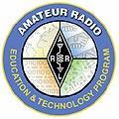
2017 ARRL Teachers Institute Application for
Remote Sensing and Data Gathering (TI-2)

Dates: July 10-13, 2017
Location: ARRL Headquarters, Newington, CT

Application deadline is May 1, 2017

Please complete the application electronically. Instructions for submitting the application are provided in section 9.

Date:

1. Teacher Information
Note: Be sure to include contact information that is good during school and summer (phone number, address, e-mail). Make sure the e-mail address(es) you provide (at school and/or at home) will accept e-mails from “@arrl.org.”

Name: Ham Radio Call Sign (required):

Home mailing address:
Street or PO Box:

City: State: Zip:

Home phone: Cell phone:

Personal/Home E-mail address:

School Email address:

In case of emergency please contact:
Name: Relationship:
At phone #:

Primary grade level taught:

Primary subject(s) taught:

2. School Information

School district:

School name:

Complete school mailing address:
Street address line 1:
Street address line 2:

City: State: Zip:

School Phone:

School (District) Federal Tax ID #:

Please provide some demographic information:

How would your local school community be classified?
Urban
Suburban
Rural
Other, please describe

Is the school:
Public
Parochial
Private
Other, please describe:

Grade levels of instruction in the school (ex: Middle School 6-8):

What is the population of the school?

How many students will receive the benefit of your participation in this training?

The percentage of the overall student population:
Who are eligible for free or reduced priced lunches %
Who are eligible for Title 1 services %
Who receive special education services %

3. Essay (attach a few typed paragraphs). Please include responses to the following questions.
- When did you attend ARRL’s introductory Teachers Institute (TI-1)?

- Describe the ways that you have used the content presented during the introductory TI-1 to enhance your instruction. Feel free to include video of any classroom activities or other documentation of instruction with students that resulted from your participation in the TI-1.

- What do you hope to learn from TI-2? How do you plan to use the content/training provided in the Remote Sensing Teachers Institute?

4. Describe your ham radio, on the air, experience:

5. Equipment Requirements for the TI2 Remote Sensing and Data Gathering
(a copy of this list is provided at the end of the application to print and retain for reference)

The following computer equipment is REQUIRED for participation in the TI2 Remote Sensing Class. Review the list and make sure that you can comply. If you have questions, please direct them to etp@arrl.org or call Debra Johnson at (860) 594-0296.

Computer equipment:

- Laptop running Windows XP or later with at least 2 operating USB ports.

- It is essential that you have full administrative privileges for the computer. You will be installing a number of 3rd party software packages on these computers that are required for the successful completion and participation in the class. If you are going to use a school computer (this is not recommended), make absolutely sure from your IT people that you have full administrative access to the computer.

Outside TI computer software required. You will need to have an operative copy of Microsoft Excel installed on your computer. You need to be able to make spreadsheets, not just read them, so make sure you are not limited to “Read Only” software.

Volt-Ohm Meter. You will need a volt-ohm meter and probes, and you should be familiar with the operation of the meter. The meter that you received during TI-1, is more than adequate. Make sure it works (make sure the current fuse isn’t blown) and you have a good battery in it.

Parallax BOE-BOT®. You will be using the basic BOE-BOT during the class. You will not need any of the ancillary electronics components used during the robot section of the basic TI like the LEDs, jumper wires, resistors, etc. You will need the appropriate cabling to program the Basic Stamp of the BOT, and the Basic Stamp editor software installed on the computer. You should also bring the instructor’s board received during TI-1. (It plugs into the top of the BOE-BOT). Review programming the Basic Stamp, and ensure you have fresh batteries and that the tires (the rubber on the wheels) are in good shape.

Calculator. Bring a scientific calculator that you know how to operate. You are welcome to use the Windows calculator if you are familiar with it.

6. Requirements to participate (initial each item to acknowledge):

Participant must bring equipment as specified in item 5 above.

Participant must be an ARRL member. (Please find information about joining or renewing ARRL membership at https://www.arrl.org/join-arrl-renew-membership/.)

Participant must complete a workshop evaluation at the conclusion of the workshop. After returning to the classroom, participant is expected to provide anecdotal feedback about the TI training and resources in use in the classroom, and from time to time, to provide valuable feedback on follow-up evaluations or surveys.

Participant is expected to contribute to an ETP resource library by sharing classroom activity ideas, lesson plans and instructional materials employing the training and resources received.

A $100 enrollment fee is required with your application. Please attach a check made payable to ARRL Teachers Institute, or call our office if you would like to pay using a credit card. Your check will be deposited and cleared through ARRL’s bank account. Your enrollment fee will be refunded should you not be accepted. After you have been accepted, if there are circumstances which prohibit you from attending and you provide us with 30 days advance notice of cancellation, we will refund the enrollment fee.

Participant is expected to pay for hotel and travel expenses and be reimbursed via expense reimbursement request that is submitted at the conclusion of the Teachers Institute. Participant must submit receipts for hotel and travel expenses to be reimbursed. Expect approximately 2 weeks to process the reimbursement.

Expenses that are covered by the ARRL Education & Technology Program Fund include: hotel accommodations for up to 5 nights (a block reservation will be made at a selected hotel), and up to $600 travel toward travel expenses (receipts required). Reimbursement will be made according to the criteria attached and within the limits specified. To receive full reimbursement under this formula, participant must attend all four days of Institute activities. A $35 per-diem for meals for up to 5 days will also be provided.

The Teachers Institute is conducted from 8 a.m. to 4 p.m. each day of the Institute. Attendance is required for the full scheduled time. Participants should expect to arrive the day before the Institute, and should schedule departures after 6 pm on the final day of the Institute or the day after the Institute. Early departures on the last day of the Institute to meet flight schedules are not acceptable, important material is covered right up to the end of the final day. Hotel accommodations are planned for arrivals the day before and departures the day after the Institute (5 nights total). Expenses for accommodation for additional days or at other locations than the designated hotel are the responsibility of the participant.

All instructional resources used during the Teachers Institute are paid for by the ARRL Education & Technology Program Fund.

The Teachers Institute is a professional development activity and therefore children would not be appropriate at the Teachers Institute. There are no accommodations for child care.

I have read and will follow the ARRL Teachers Institute Travel and Reimbursement Guidelines and Procedures.

7. Signatures

___________________________________ ____________________________________
(type or print your name here) (type or print Administrator’s name here)

___________________________________ ____________________________________
(your signature) (Administrator’s signature )

8. Pre-workshop survey
Please complete the attached Pre-workshop Survey to submit with your application. The survey must be submitted to complete your application.

9. Submitting the application
You can print your completed and signed application and to send along with the completed Pre-workshop Survey and the cover letter. Enclose the $100 enrollment fee and mail to:
ARRL
Education & Technology Program
Attn: Debra Johnson, Education Services Manager
225 Main Street.
Newington, CT 06111-1494

If you wish to pay your enrollment fee by credit card, please contact Debra by phone at 860 594-0296, or Amy Leary at (860) 594-0243.

Before mailing, please refer to the application checklist to be sure you have submitted all required items.

You may fax the signed application, survey and cover letter to (860) 594-0259. Please include a fax cover sheet with instructions: Attn: Debra Johnson.

Or, you may scan and send your cover letter, application and completed survey electronically, to Debra Johnson, at djohnson@arrl.org. Please include your name in the document title for all electronic documents you submit. For example: “DJohnson_TI application 2017”.

To be considered, your completed application, Pre-workshop Survey and enrollment fee must be received at ARRL by the application deadline, May 1, 2017.

10. Admission decision announcements

We will make every effort to advise you of our decision on your application and your session assignment by May 15. We will contact you at the email address you have provided. If you have not heard from us by that date, please feel free to contact us.

Questions?
Please direct questions regarding your application for the Teachers Institute to etp@arrl.org or call Debra Johnson at (860) 594-0296.

TI-2 Remote Sensing and Data Gathering
Application Checklist

Application deadline is May 1, 2017

Please be sure you include all of the following to complete your application:

- Cover letter on school letterhead stating your desire to attend, signed by you and a school administrator.

- Completed application form with signatures.

- Completed Pre-workshop Survey (item 8)

- Check or credit card payment for $100 enrollment fee, payable to ARRL Education & Technology Program. If the session you want is full or if you are not accepted, the enrollment fee will be refunded.

- If you are not already a member, check or credit card payment for $49 for ARRL membership, or join or renew online at https://www.arrl.org/join-arrl-renew-membership

TI-2 Remote Sensing Pre Workshop Survey 2017

Complete this short survey that includes questions on a few of the concepts that will be presented during the Teachers Institute. Your answers should be short, concise, and oriented to how you would present the concepts in your classroom.

It is not expected that you will readily be able to answer the questions on this survey—it is being used to gauge your current knowledge of the content presented during the TI-2 and to provide you with a preview of the workshop content. We realize that most teachers do not have knowledge or preparation to teach concepts that the Teachers Institute focuses upon—that’s why we offer this professional development opportunity. Please feel free to make use of open sources to answer the questions. If you do need to look up some topics to reply to a question, please restate information using your own words.

Another purpose of this survey is to gain some background information on your comfort level with the material so that the curriculum and presentation of the content during the Teachers Institute can be adjusted to better meet the needs of the participants.

In the box before each question, please use the following scale to help us plan for a productive session.

- I totally get this, in fact, I could teach it tomorrow if asked.
- I could teach this to students, but I will need to review.
- This one took quite a bit of work, but I am pretty sure I got the correct answer.
- I really didn’t know where to start, so I had to Google it, research it, or call a friend.

- Describe what you would expect the temperature profile (temperature over time) to be if you were to measure air and water temperature at a local pond of water? Use a simple hand drawn graph to illustrate your point.

- What part of the Earth most influences global climate?

- Relate the concepts of hysteresis and specific heat to your local climate.

- Explain how a heavy object, like a boat with a concrete hull, is able to float in water?

- You have a rectangular solid object that has dimensions 5cm x 5cm x 10cm and it has a mass of 245 grams. Will this object float or sink when you place it in water?

- The formula required to convert the voltage, in ADC, to measured temperature in degrees K is:
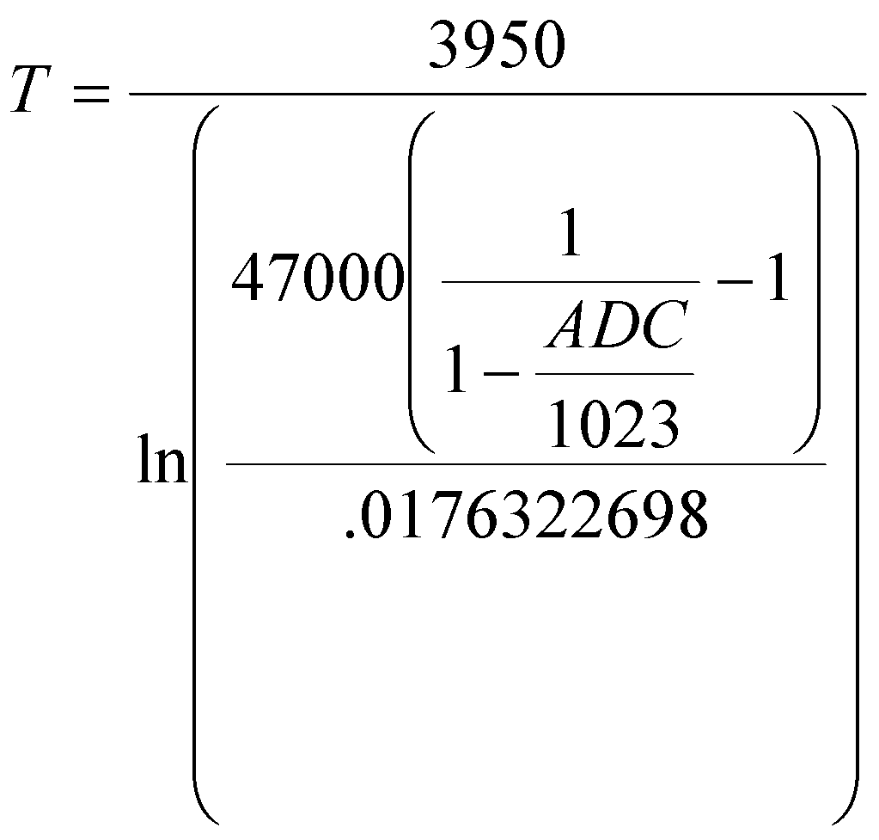
If ADC = 455, calculate the temperature in degrees C.

- Use the following ADC temperature readings to create an Excel spreadsheet that converts the ADC readings into Degrees C and then plots the data in an Excel generated graph using the formula and other information in the question above:
260, 272,262,265,288,298,298,281,282,271,270,267,268,277,280,276,274, 271,269,269,265,257,234,218

Please send an electronic copy of your Excel spreadsheet to djohnson@arrl.org. Reference “TI-2 application, Q7”, and your name in the subject line.

- What is the voltage at point A in this circuit?
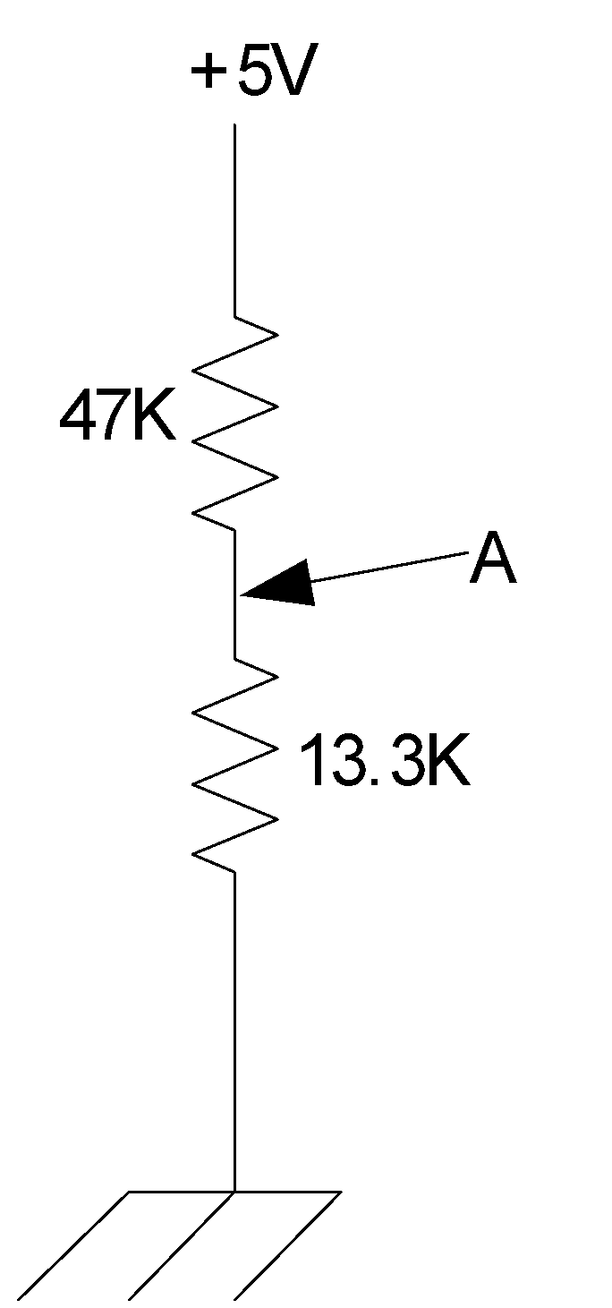

- Map coordinates are used in 3 basic formats depending on the presentation of the map being used. These formats are as follows with d=degrees, m=minutes, and s=seconds:
ddd.ddddd
ddd mm.mmm
ddd mm ss.s
Convert the following coordinates in the ddd.ddddd format into the other two formats:

N41.4059

W72.0805

- Using an on-line source or mapping program, identify the town near these coordinates. Identify the source you used to find this location.

- The following Basic Stamp subroutine is used to turn the robot left a specified number of degrees of turn (number of degrees passed in the variable cmd). The amount of turn the robot makes is very dependent on the surface upon which the robot is operating, i.e., surface/tail wheel friction is significant. What variable will need to be adjusted by testing to compensate for the unique surface friction?
left:
degrees =((cmd(counter1+1)-48)*100) + ((cmd(counter1+2)-48)*10)+(cmd(counter1+3)-48)
degrees=degrees/5
FOR counter= 1 TO degrees
PULSOUT 13, 650
PULSOUT 12, 650
PAUSE 20
NEXT
PAUSE 200
RETURN 'left

What variables or numbers in the above subroutine would need to be changed to make the routine usable for making a right turn?

- The following Basic Stamp command statement is useful for receiving unique information from an outside source via a data link receiver. Explain each part of this command. [Hint: look in the Help section of the Basic Stamp Editor program.]
SERIN 15, 813,[WAIT ("MAREA") ]

- You want to send a decimal value of 153 to a computer running Excel. Excel will only accept data into a cell that is in ASCII format. Convert the decimal 153 numbers into the ASCII equivalents for transmission to the computer. Develop a simple formula (algorithm) to make the conversion.

- What kind of sensors are you interested in learning about or would like to use in your classroom?

Equipment Requirements for the TI-2 Remote Sensing and Data Gathering
(retain this list for reference)

The following computer equipment is REQUIRED for participation in the TI-2 Remote Sensing Class. Review the list and make sure that you can comply. If you have questions, please direct them to djohnson@arrl.org or call Debra Johnson at (860) 594-0296.

Computer equipment:

- Laptop running Windows XP or later with at least 2 operating USB ports.

- It is essential that you have full administrative privileges for the computer. You will be installing a number of third party software packages on these computers that are required for the successful completion and participation in the class. If you are going to use a school computer (this is not recommended), make absolutely sure from your IT people that you have full administrative access to the computer.

Outside TI computer software required. You will need to have an operative copy of Microsoft Excel installed on your computer. You need to be able to make spreadsheets, not just read them, so make sure you are not limited to “Read Only” software.

Volt-Ohm Meter. You will need a volt-ohm meter and probes, and you should be familiar with the operation of the meter. The meter that you received during TI-1, is more than adequate. Make sure it works (make sure the current fuse isn’t blown) and you have a good battery in it.

Parallax BOE-BOT®. You will be using the basic BOE-BOT during the class. You will not need any of the ancillary electronics components used during the robot section of the basic TI like the LEDs, jumper wires, resistors, etc. You will need the appropriate cabling to program the Basic Stamp of the BOT, and the Basic Stamp editor software installed on the computer. You should also bring the instructor’s board received during TI-1. (It plugs into the top of the BOE-BOT). Review programming the Basic Stamp, and ensure you have fresh batteries and that the tires (the rubber on the wheels) are in good shape.

Calculator. Bring a scientific calculator that you know how to operate. You are welcome to use the Windows calculator if you are familiar with it.

ARRL Teachers Institute Travel and Reimbursement Guidelines and Procedures
Remote Sensing & Data Gathering 2017
(please review and retain this document for your reference)

You must supply receipts for all reimbursable expenses. You will be asked to complete an expense report at the close of the workshop. We will provide a form for you to summarize your reimbursable expenses and attach relevant receipts. To receive full reimbursement for expenses, you must attend all four days of Institute activities.

We expect that you will be as practical and judicious as possible in your decisions about travel to get to the workshop, to help steward the program resources as much as possible.

Your travel expenses are reimbursable up to a $600 limit (this includes all travel expenses including travel to airport, baggage, fees, taxis and shuttles, parking, mileage and air fare). We expect that you will make your travel plans as soon as we have confirmed your enrollment in the program. Please make your reservations as soon as possible to take advantage of lower advance air fares. If you have questions about the appropriate destination airport convenient to the workshop location, please contact our Program Administrator. Be advised that we will reimburse for coach air fare only, no upgrades and only for the reasonable and customary fare for an advance purchase coach ticket. If you are planning to travel to the Teachers Institute by way of another destination or if you are delaying making your travel plans for some reason please keep this in mind.

You may apply for mileage reimbursement for your travel in your personal vehicle to and from the airport nearest your home. If you decide to drive your personal vehicle to the workshop, we will reimburse you at the IRS approved mileage rate paid for ARRL company travel, up to the cost of an advanced purchase coach class air fare, or the $600 travel limit, whichever is less.

In some situations, with extenuating circumstances we will reimburse travel cost in excess of the $600 limit, but only if prior approval has been given. We will not reimburse your total cost of travel in excess of the $600 limit unless you have received prior approval.

We ask participants who have their personal vehicle available at the workshop location to provide transportation to and from the hotel and workshop site for other participants who have traveled by air. Reimbursement for a personally owned vehicle’s mileage while in use to facilitate group transportation during the workshop will not be deducted from the owner’s $600 travel allowance.

We require that you receive prior approval from us if you want to be reimbursed for a car rental. Generally renting a car to travel to the workshop from a distance is not cost effective. Rental companies frequently charge surcharges for interstate travel, and if extra insurance is necessary, what appears to be a good deal can suddenly become very expensive. We want to assure that there is sufficient transportation available to accommodate all participants between the hotel and classroom and to local eating establishments so a limited number of car rentals will be needed for each workshop session if there are not sufficient personally owned vehicles available. With this in mind, to receive reimbursement for a car rental you must receive prior approval from the ARRL Program Administrator who will coordinate the local transportation needs for the group. If we have approved your car rental, retain gas receipts for reimbursement of fuel expenses as well as the rental contract receipt.

Hotel accommodations are reimbursable for your stay, arriving the night before the program begins and during the workshop, and including the last night of the workshop (up to 5 nights maximum), at the hotel designated for the workshop group reservation. We will not reimburse for lodging at locations other than the designated hotel. Rooms for the attendees will be reserved by the Program Administrator. You should be prepared to provide your own credit card upon check in at the hotel and get a copy of your hotel invoice to file with your expense report on the last day of the Teachers Institute workshop. Expenses for accommodation for additional days are the responsibility of the participant.

We will reimburse only for the hotel room: no movies, bar and amenities, phone calls, gratuities, Internet connection. Please let us know if you have other arrangements for lodging and will not need hotel accommodations. A few weeks before the start of the workshop we will confirm your hotel reservations with you and provide your reservation confirmation number.

You will also receive a flat per diem of $35 to help defray the cost of your meals. No receipts for meals are necessary. This per diem will be provided for the four days of the workshop plus one extra day of travel. This per diem is intended for participants who are not in residence locally. Local participants can also apply for a reduced per diem to cover their cost of meals while attending the workshop.

Your check for your enrollment fee will be deposited and cleared through ARRL’s bank account. Your enrollment fee will be refunded should your application not be accepted. After you have been accepted and enrolled in a session, if there are circumstances which prohibit you from attending and you provide us with 30 days advance notice of cancellation, we will refund your enrollment fee.

Expense reports are submitted to ARRL headquarters at the close of the workshop. If any questions arise as they are reviewed, you may be contacted to clarify your report. Reimbursements are usually mailed within 2 weeks of the close of the workshop.

If you have any questions about these guidelines, please contact us at djohnson@arrl.org or (860) 594-0296.

