ARRL’s sample World Amateur Radio Day Media Advisory
Use radio club letterhead. Keep to a single page.
Contact:
[LOCAL CONTACT’s NAME] [LOCAL CONTACT’s TITLE, if any]
[EMAIL]
[PHONE]
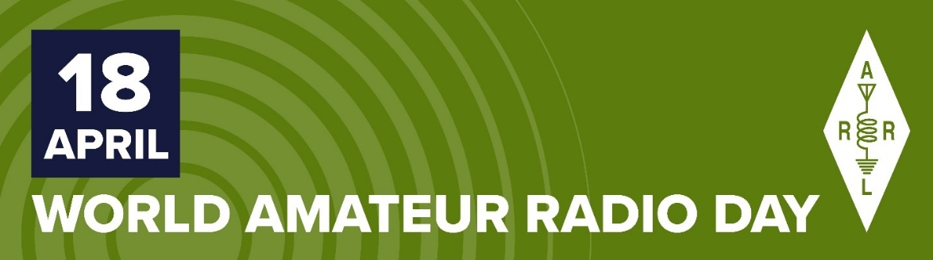
MEDIA ADVISORY
2022 World Amateur Radio Day — Monday, April 18
[alt headline] Discovering Radio Communications through Ham Radio

2022 World Amateur Radio Day (WARD) is Monday, April 18. On World Amateur Radio Day, radio amateurs, also known as ham radio operators, take to the airwaves to enjoy their global friendship, and to demonstrate their skills and capabilities to the public in their common pursuit of radio communications and radio technology. It was on this day in 1925 that the International Amateur Radio Union was formed in Paris, France. WARD celebrates the pioneering achievements and ongoing service of the ham radio community.

ARRL The National Association for Amateur Radio® (www.arrl.org) in the US, reports that there are more than 3,000,000 radio amateurs throughout the world. ARRL includes 2,400 affiliated radio clubs nationwide. Members of local radio clubs, including ________[name of your club] in ________[name of your community], provide opportunities for newcomers to discover radio and to become ham radio operators. They work together to develop their personal radio communications capability, operating their stations from their homes and in portable settings from nearly anywhere. Their use of radio signals, which reach beyond borders, brings people together culturally while providing essential communication in the service of communities.
In today’s electronic do-it-yourself (DIY) environment, ham radio remains one of the best ways for people to learn about electronics, physics, meteorology, and numerous other scientific disciplines. Some hams, including members of the ________[name of a local ARES® or other public service group] train throughout the year to serve their communities during emergencies and disasters, such as hurricanes and wildfires, if the standard communication infrastructure goes down.

There are hams of all ages, from 9 to 100. Many radio clubs provide support and training to help newcomers pass an Amateur Radio License examination. A self-study license guide is available from ARRL: The ARRL Ham Radio License Manual (www.arrl.org/shop/Ham-Radio-License-Manual) and for Kindle (www.amazon.com/dp/B07DFSW94G/ref=cm_sw_em_r_mt_dp_U_63WmEbTX76KAB).

For more information about World Amateur Radio Day and ham radio, contact ________[club or personal contact info] and visit www.arrl.org/what-is-ham-radio. Look for #WorldAmateurRadioDay posts on social media.
###

